IFRS 9 Session 2 Notes
The business logic behind a loan, how a bank records income and expense, and why provisions are needed in the first place.
Simple idea: a bank collects money from depositors, lends that money to borrowers, and earns interest.
The danger is that some borrowers may not repay.
That is why banks keep aside provisions.
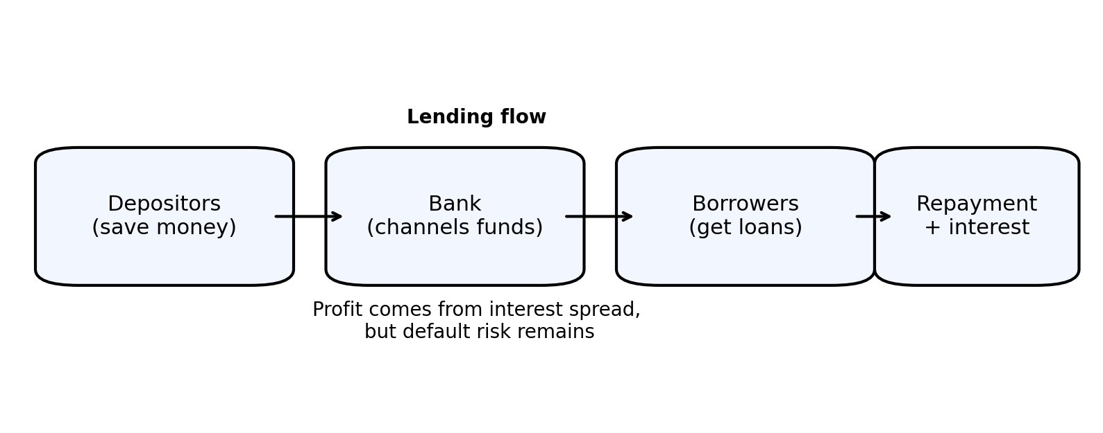
Figure 1. Basic bank lending flow

2. Retail portfolio vs commercial portfolio
The bank’s lending book is split into two broad buckets: retail and commercial.
Explains that retail portfolios usually have many borrowers with small average exposure, while commercial portfolios usually have fewer borrowers with much larger exposure.
- Retail: many accounts, small exposure per account.
- Commercial: fewer accounts, high exposure per account.
Why this matters: retail modeling often has enough data because the number of accounts is large. Commercial portfolios can be low-default portfolios, so finding enough default cases becomes harder.
Retail portfolios often use logistic regression, while commercial portfolios may use methods like the Pluto/Tasche approach.
That is simply a way of saying: the modeling tool depends on the type of portfolio and the amount of default data available.

3. Basel retail classification
Retail assets into three broad buckets under Basel: revolving retail exposures such as credit cards and overdrafts, mortgages, and other retail loans such as personal loans and auto loans.
Bucket | Examples / meaning
Revolving retail exposure | Credit cards, overdrafts, open-ended products.
Mortgages | Home loans backed by the house itself.
Other retail | Personal loans, auto loans, and similar products.

Important learning point: in Basel, the classification is driven mainly by risk behavior and exposure pattern. A credit card behaves very differently from a mortgage, so Basel separates them.

4. How a bank’s P&L works
The profit and loss statement in a very simple way: income minus expenditure gives profit or loss.
- Income can be interest income and non-interest income.
- If provisions go up, dividends usually go down.

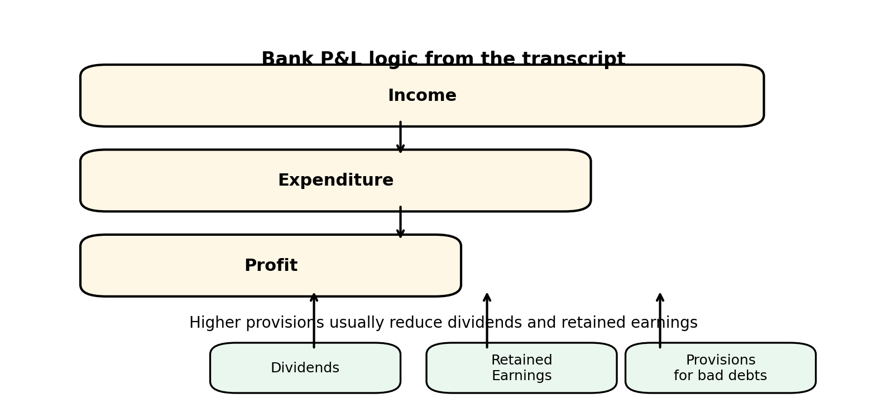
Figure 2. Simplified P&L waterfall
Lower provisions may make shareholders happy in the short run, but insufficient provisioning can hurt the bank later.

5. Why provisions are not enough: loss distribution idea
A key diagram shows loss values on one side and frequency on the other.
The idea is that expected losses happen more often but are usually smaller.
Unexpected losses happen less often but can be much larger.

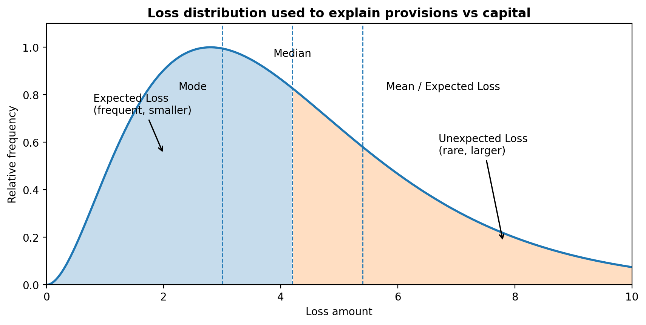
Figure 3. Loss distribution used to explain expected loss and unexpected loss
Expected losses are usually covered by provisions. Unexpected losses are the reason banks need capital.
Provisions are for expected loss, while capital is for unexpected loss.
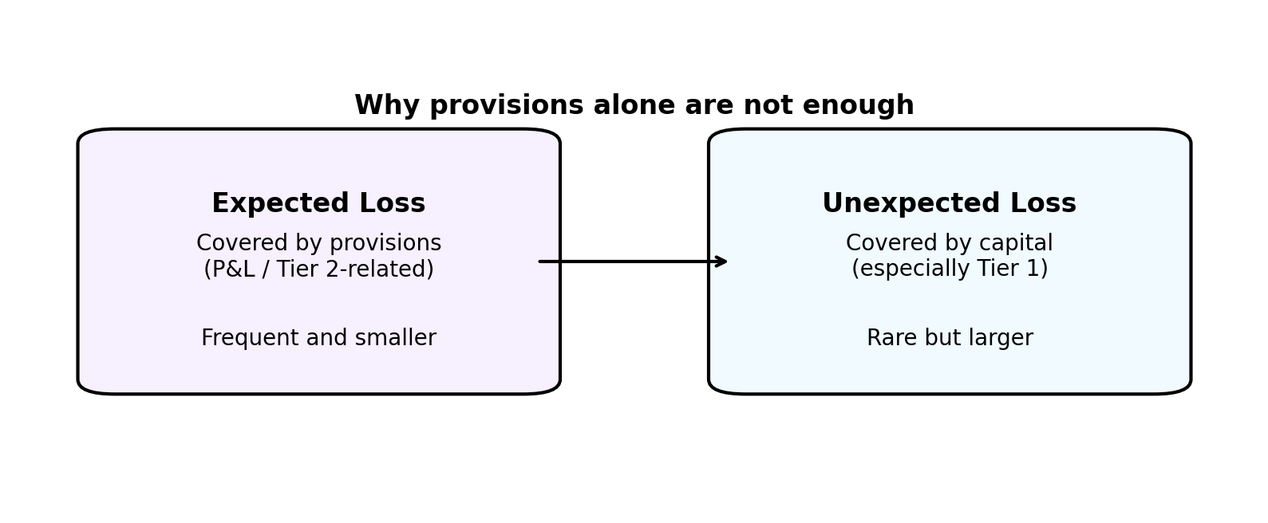
Figure 4. Provisions vs capital

6. Capital levels
The tier 1, tier 2, and tier 3 capital.
The main practical point discussed is that unexpected losses are absorbed by tier 1 capital. Expected losses are linked to provisions and allowance for loans and losses, closer to tier 2 treatment.
- Tier 1 capital: pure equity capital, used for unexpected losses.
- Tier 2 capital: subordinate / estimated capital, linked to provisions and expected losses.
- Tier 3 capital: mentioned, but not discussed in detail in the session.
The point that Basel / capital adequacy frameworks and IFRS 9 are not the same thing.
They solve different problems, even though both help protect the bank.

7. Personal loans: the first IFRS 9 asset example
Personal loans are described as fixed-term and unsecured. The bank lends a principal amount, charges interest, and recovers the loan through monthly installments.
- The asset is intangible: you cannot physically hold the loan, but it creates future cash inflows for the bank.
- The payment schedule is amortized over time.
- The first EMIs usually contain more interest; later EMIs contain more principal.
Because the cash flows are contractual principal-plus-interest cash flows, this type of loan passes the SPPI test and is measured at amortized cost.
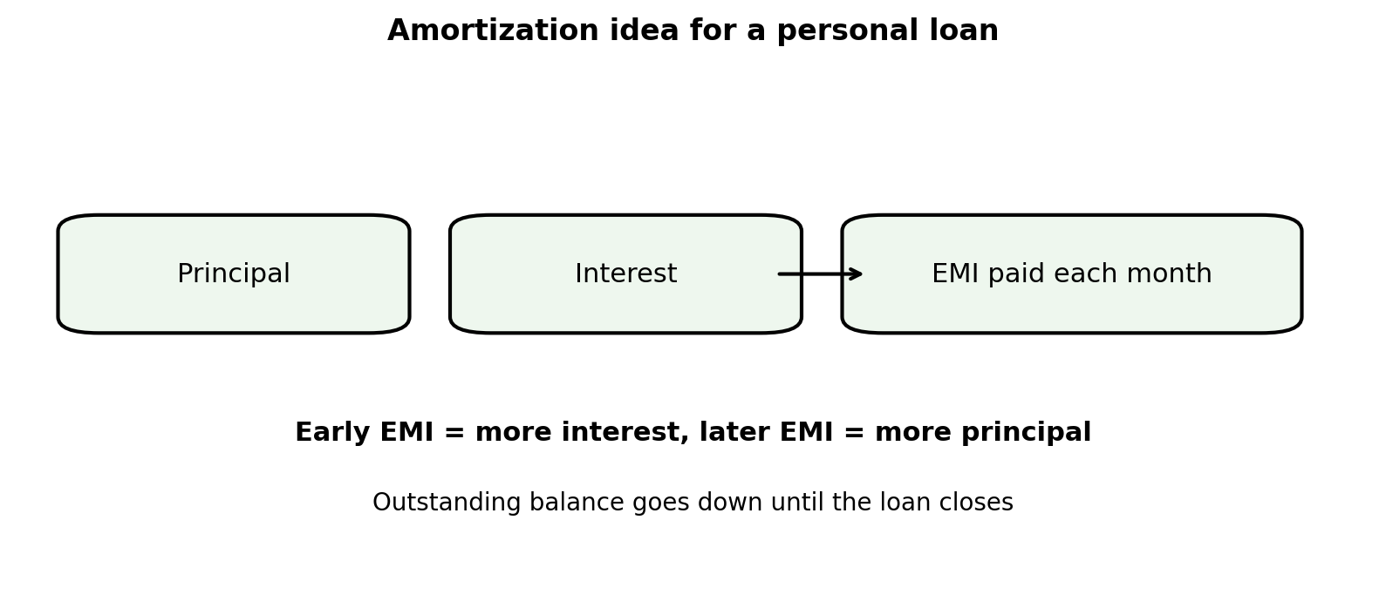
Figure 5. Amortization idea for a personal loan
The Excel example shows how the outstanding balance reduces after each monthly payment.
The loan is gradually written off the bank’s books as the borrower pays the installments.

8. EMI / amortization formula
The session uses the standard installment logic: principal, rate per period, and number of payments.
The monthly payment is derived from the loan amount, the periodic interest rate, and the total number of installments.
Symbol | Meaning
P | Principal / loan amount
r | Interest rate per period
n | Number of payments
EMI | Monthly installment amount
The exact formula is less important than the idea behind it: each payment slowly reduces principal, while interest is charged on the outstanding balance.

9. IFRS 9 expected credit loss and staging
IFRS 9 introduces two ECL horizons: 12-month ECL and lifetime ECL.
- 12-month ECL: used for accounts that are still performing and have not shown a major deterioration.
- Lifetime ECL: used when the account has undergone significant increase in credit risk or has already defaulted / become impaired.
Explains this through staging analysis:
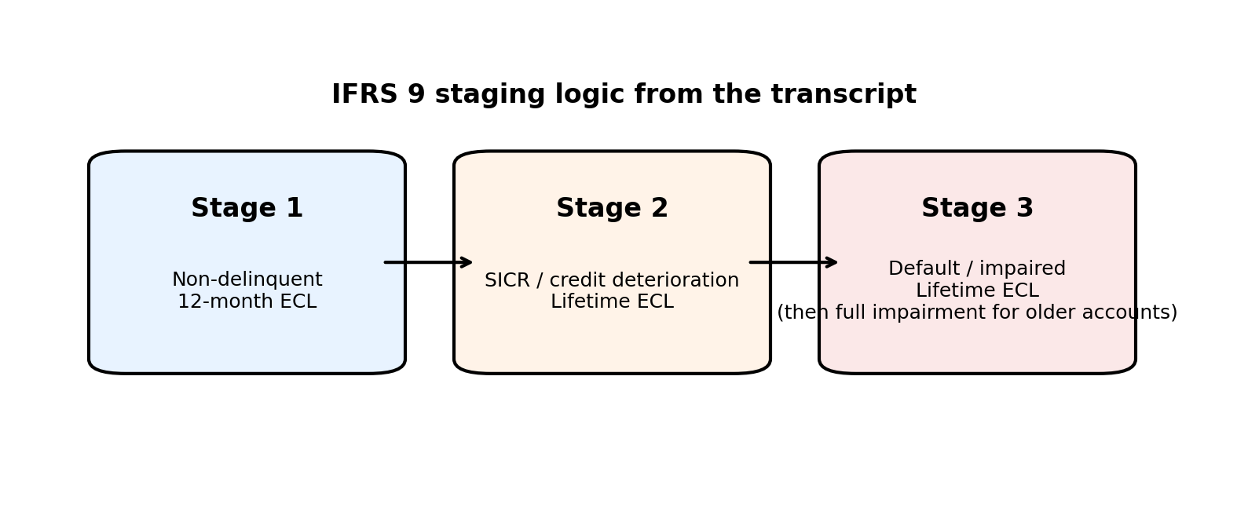
Figure 6. IFRS 9 staging logic
- Stage 1: non-delinquent accounts.
- Stage 2: accounts with significant increase in credit risk, but not yet defaulted.
- Stage 3: defaulted / impaired accounts.
A practical point is that staging is about the borrower’s repayment capacity, not just the current market value of the collateral.
Macroeconomic variables matter because IFRS 9 is forward-looking.
The exact variables depend on the portfolio.

